Homework 3 Report

Wyatt Duberstein

Task 1:

For task 1, I had a pretty simple html file that declares the 3 buttons (start/stop, turn left and turn right), and the canvas where the snake will actually be moving.



The javascript for this part was a lot more involved that I personally thought it would be, but it ended up being kind of fun. Here are some examples of the snake that I made:

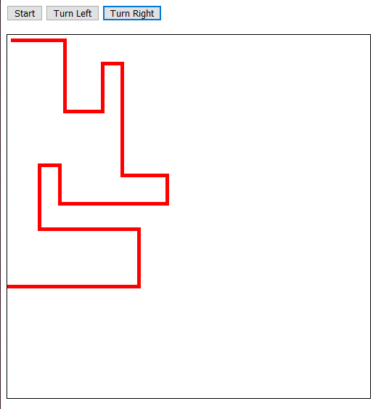

As you can see in the above picture, I was able to move the snake around the box freely, and it stopped the snake’s movement (and changed the button text to “Start” when it reached the wall. A similar effect can be seen when the snake runs into itself:

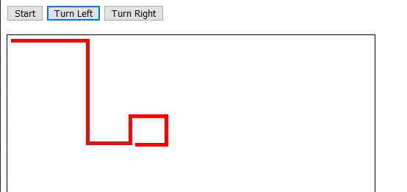

Task 2:

For task 2, I had to learn the differences in syntax between java (which I am much more familiar with) and javascript. Once I got past the language barrier, I was able to get my script to execute all of the queries it was presented with. Here are the outputs with the given example numbers:

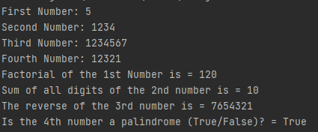

And here is the output with random numbers:

